

PRACTICAL PROJECT FILE
COMPUTER SCIENCE
CLASS: XII Science
Department Of Computer Science
Rabindra Vidya Niketan, NH-49,
Keonjhar
Odisha
Name : Shrinibas Mahanta
ROLL No. : 33

CERTIFICATE

Name: Shrinibas Mahanta Class: XII Science
Roll No: 33
Exam : AISSCE 2022-23
Institution: Rabindra Vidya Niketan, Keonjhar, Odisha

This is certified to be the bonafide work of the student in the Computer Science Laboratory during the academic year 2022-23.

No. of practical certified ___________ out of ____________ in the subject of Computer Science.

Teacher In-Charge
Date:_______________

I N D E X
Sl. No. | Name of the practical | page | Date of Submission | Signature
1 | Classification of string. | 4
2 | Dictionary displayer. | 5-6
3 | Simple and compound interest. | 7
4 | Factorial calculator. | 8
5 | Calculate upper/lower case letters. | 9
6 | Palindrome or not. | 10
7 | Total words in .txt file | 11
8 | Calculate sum of even digit from story.txt. | 12
9 | Count uppercase alphabets from poem.txt | 13
10 | rb/wb/ab to a binary file. | 14-15
11 | rb/wb and search from bin file | 16-17
12 | rb/wb and update bin file. | 18-19
13 | r/w ,append and search csv file | 20-22
14 | Stack ops program -Menu Dri. | 23-24
15 | Queries for item table. DB | 25-27
16 | Queries for club table. DB | 28-30
17 | Queries for patient table. DB | 31-33
18 | Queries for Books. DB | 34-37
Teacher’s Signature
PFQ01. Write a python program to read a string and print:
- No. of alphabet
- No. of uppercase
- No. of lowercase
- No. of digits
Program.
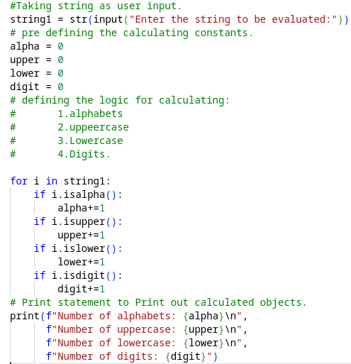
Output.
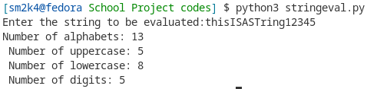 Signature

PFQ02. Write a python program to accept a dictionary by user containing 10 no.s names and classes as key - value pairs and display the dictionary.

Program.
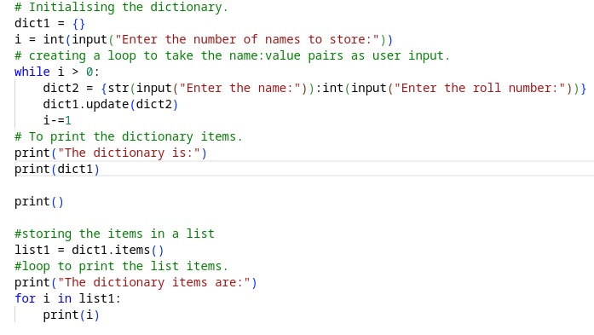

Output.
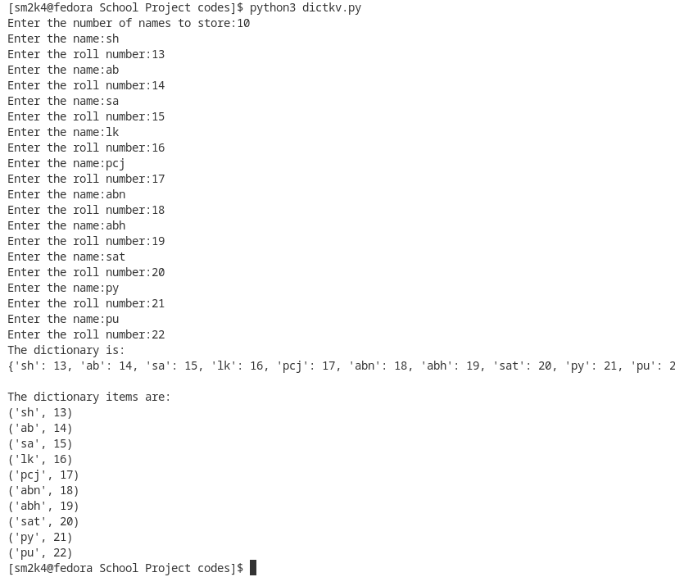

Signature
PFQ03. Write a python function to accept principal, rate and time by the user and find out the Simple Interest and Compound Interest.
Program.
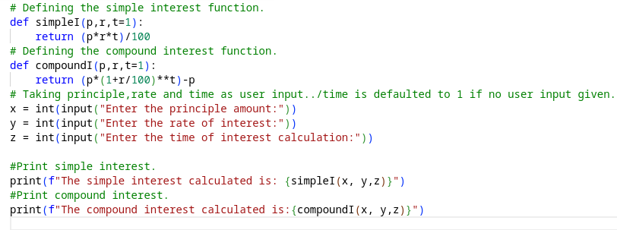

Output.
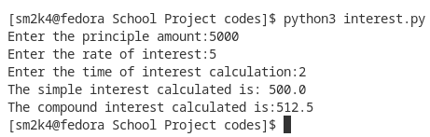

Signature

PFQ04. Write a python function to calculate the factorial of a given number.

Program.
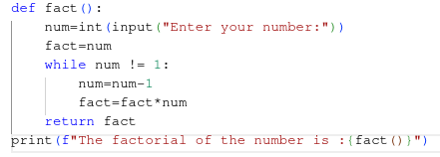

Output.
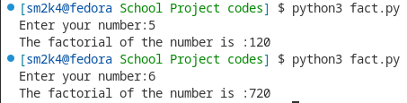

Signature

PFQ05. Write a python function that accepts a string and calculate the number of uppercase and lowercase letters.

Program.
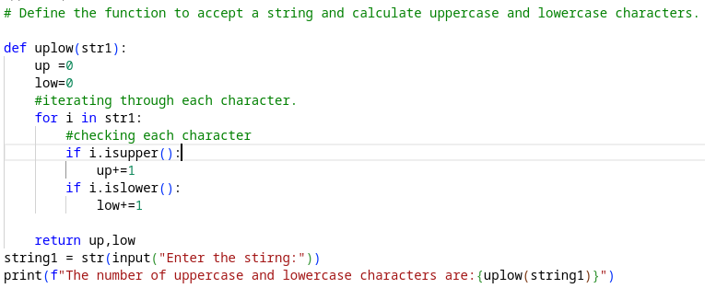

Output.
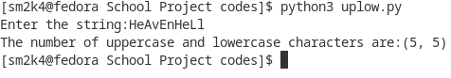

Signature

PFQ06. Write a python function that checks whether a passed string is palindrome or not.

Program.
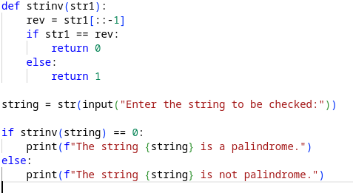

Output.
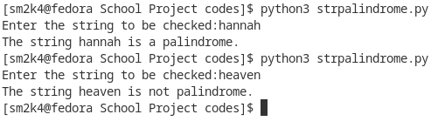

Signature

PFQ07. Write a python function to count the total number of words in a text file.

Program.
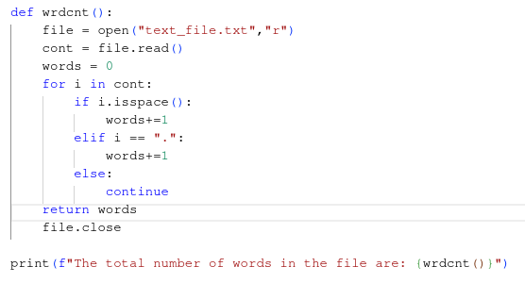

Output.
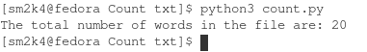

Signature
PFQ08. Write a python function to read from text file “story.txt” and calculate and display the sum of all the even digits present in the file.

Program.
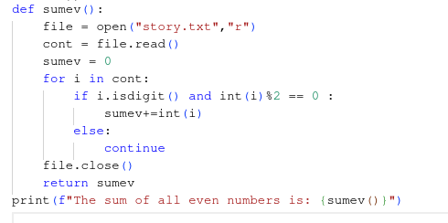

Output.
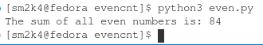

Signature

PFQ09. Write a python function to count the number of Upper-Case alphabets in a text file “poem.txt”.

Program.
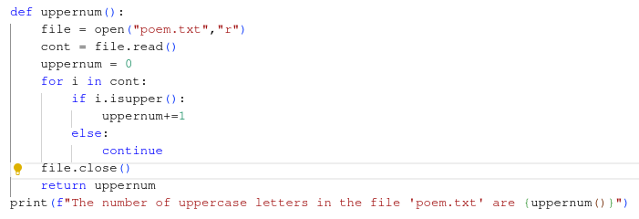

Output.
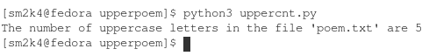

Signature

PFQ10. Write a python program to write and read data from a binary file consisting roll no, name, marks and Append more records in the same file.

Program.
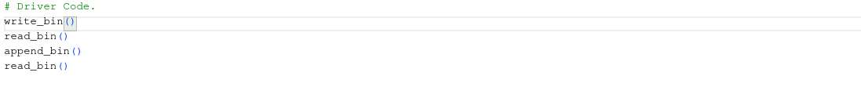
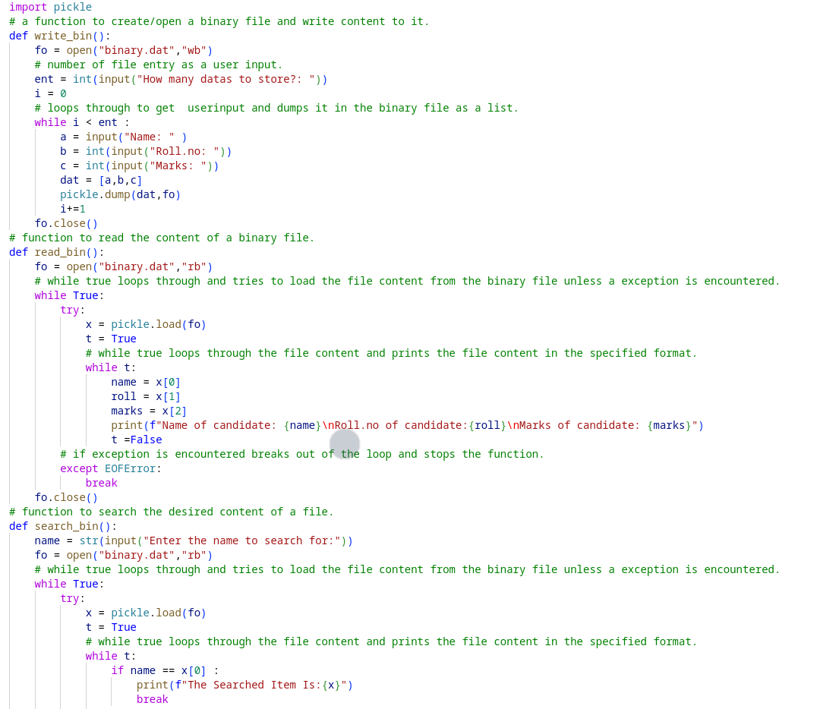
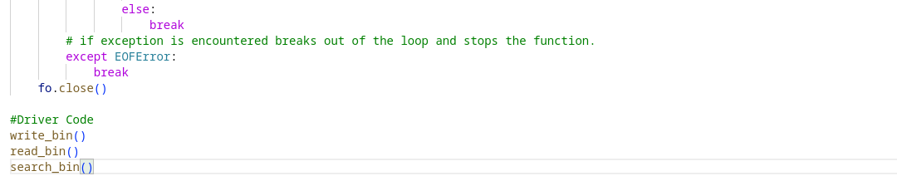
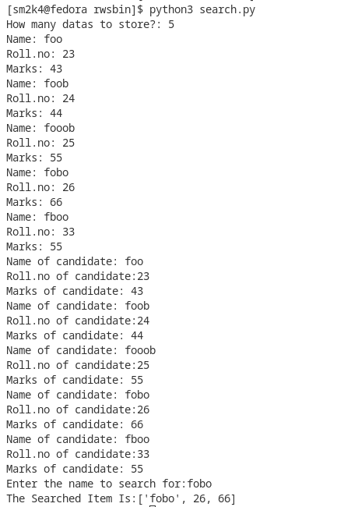
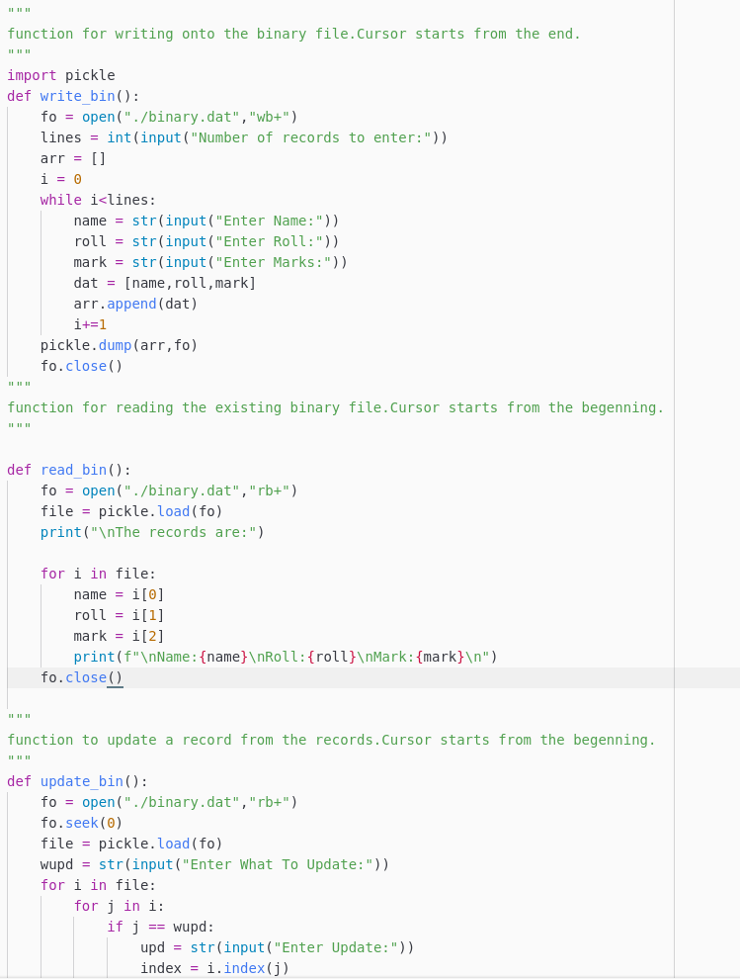
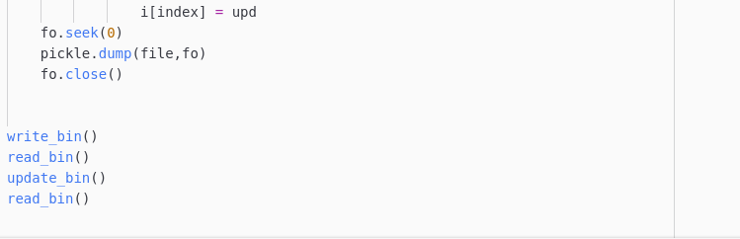
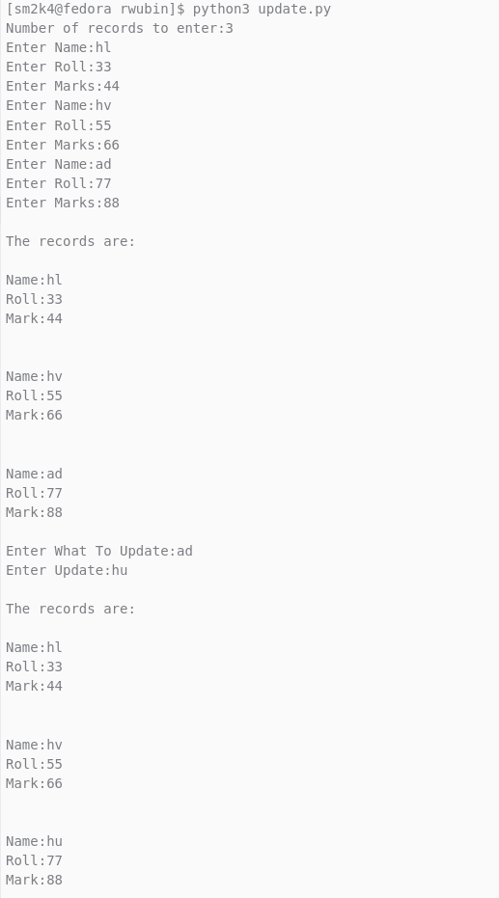
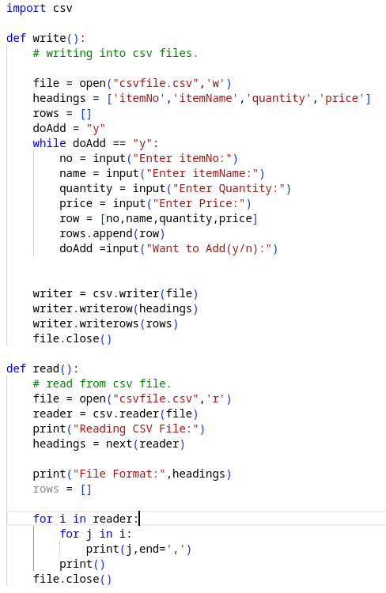
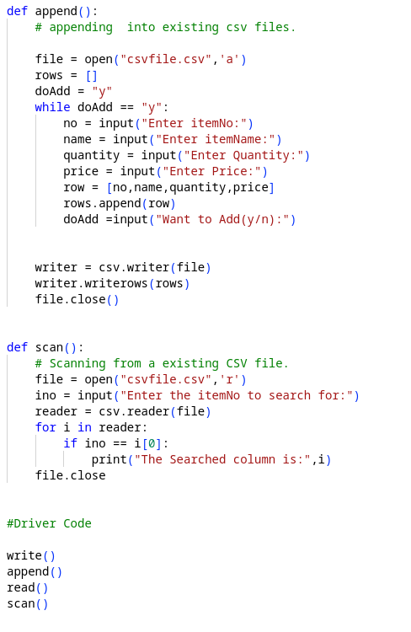
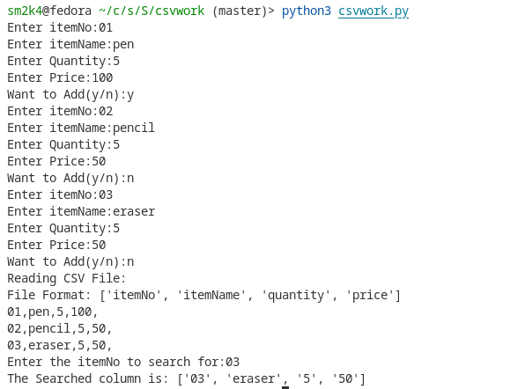
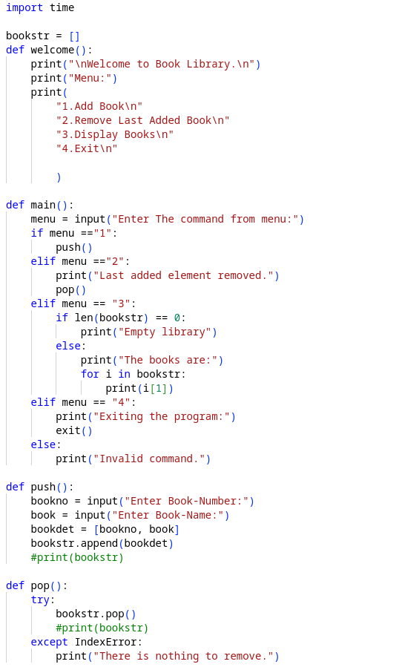
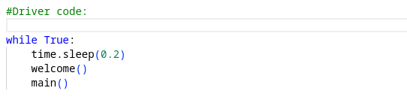
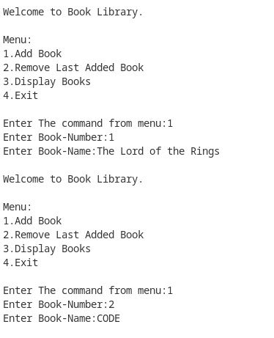
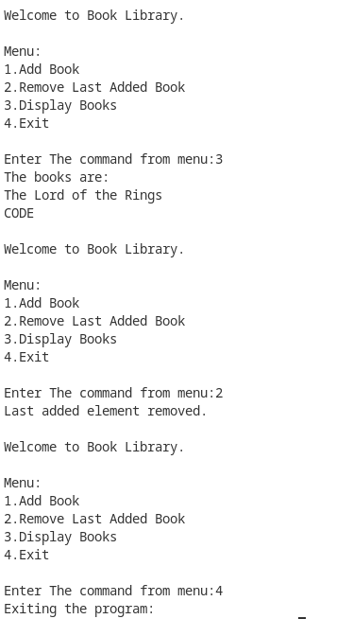
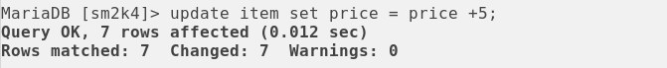
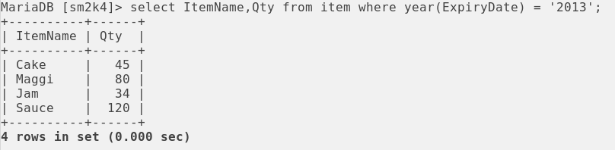
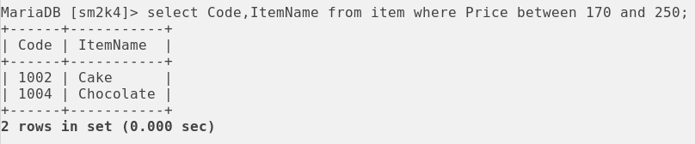
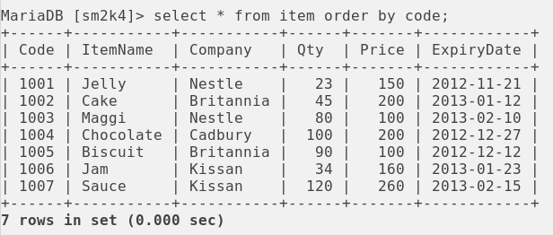
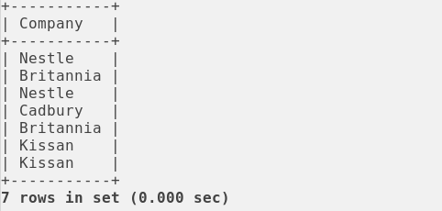
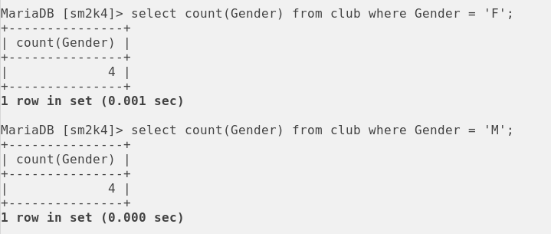
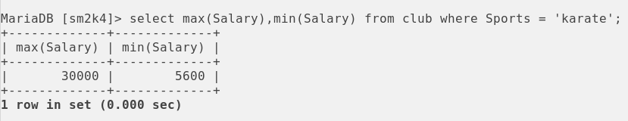
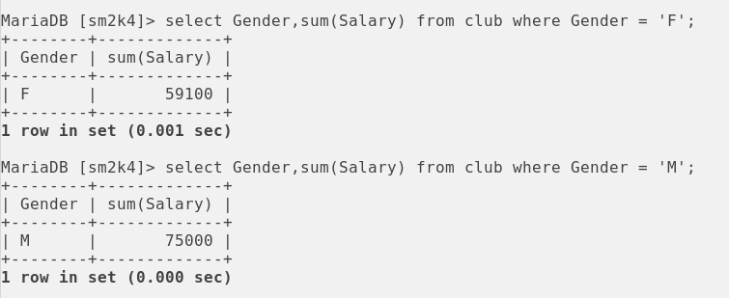
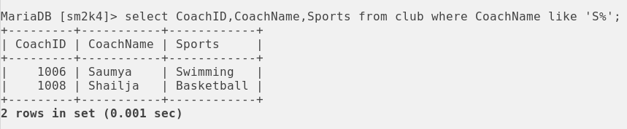
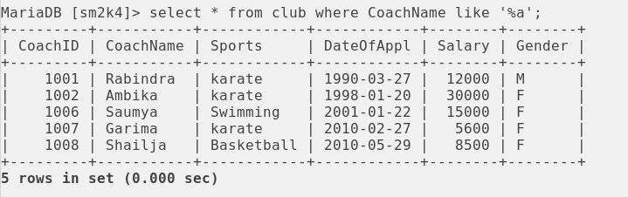
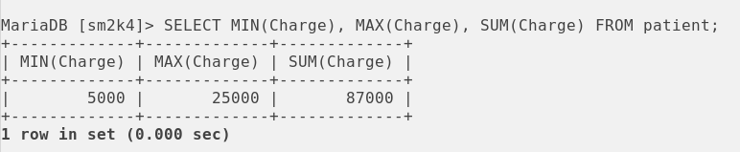
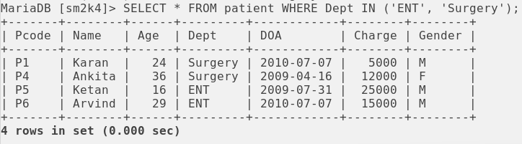
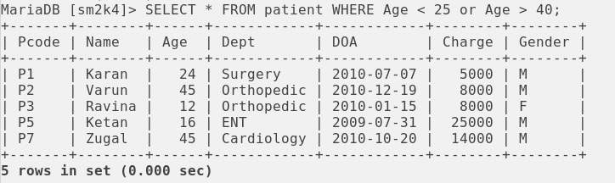
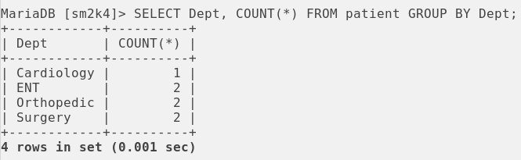
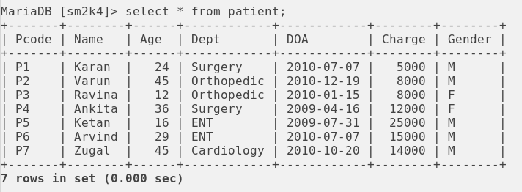
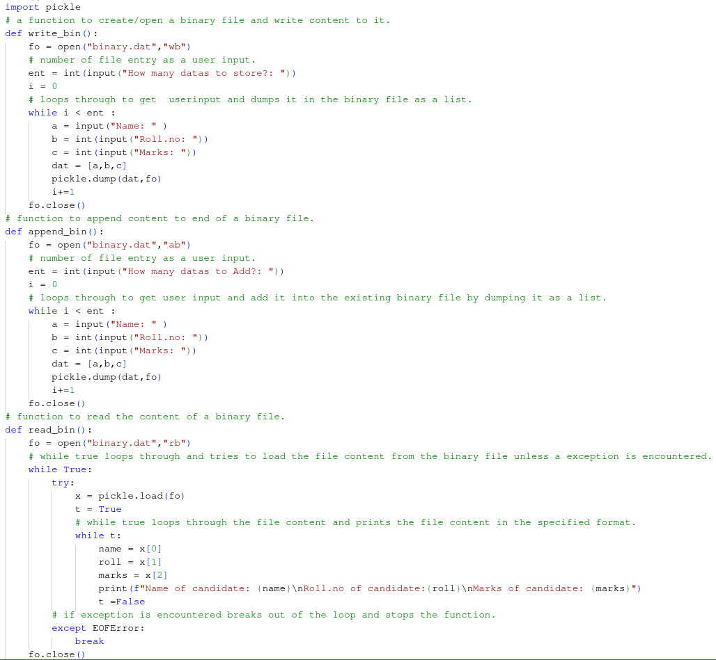

Output.
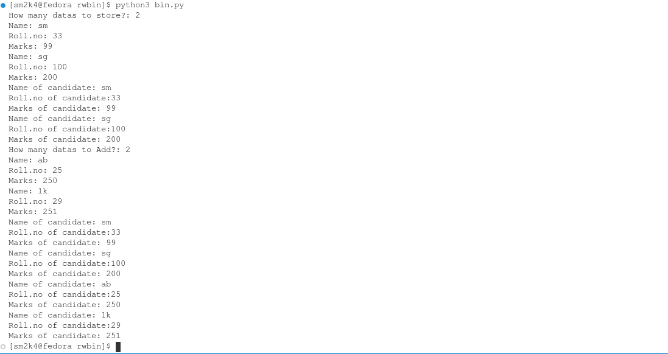
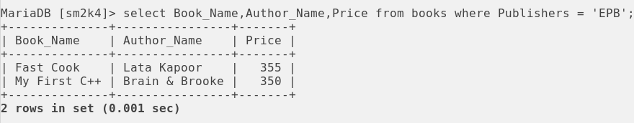
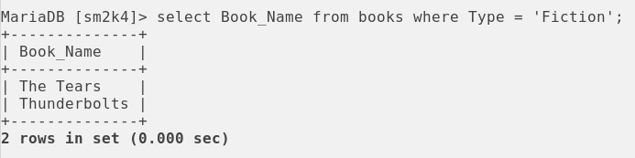
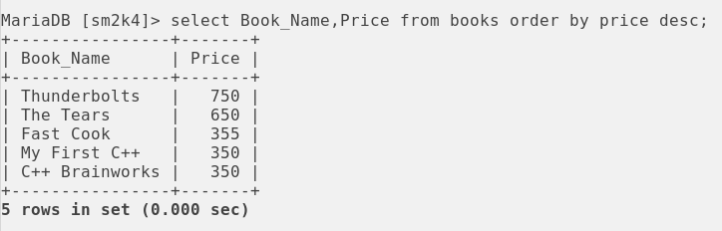

Signature

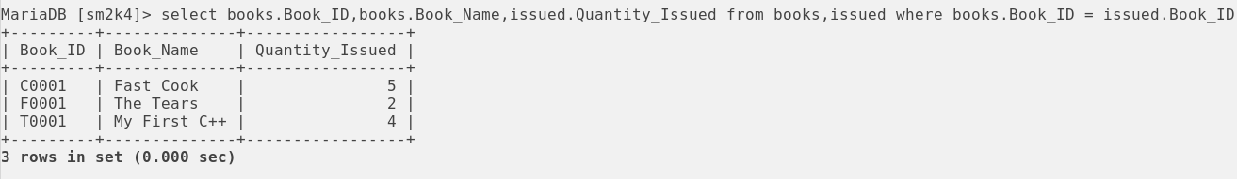
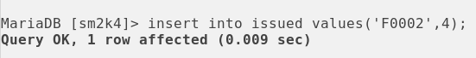
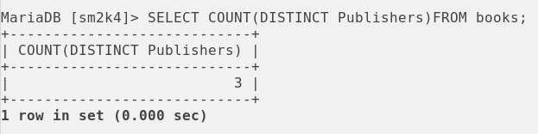
PFQ11. Write a python program to write and read data from a binary file consisting roll no, name, marks and Search for a records from the file.

Program.

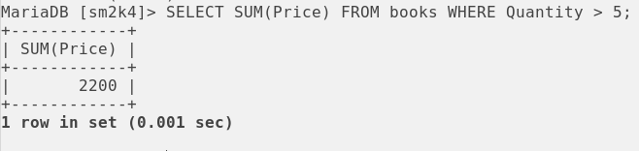
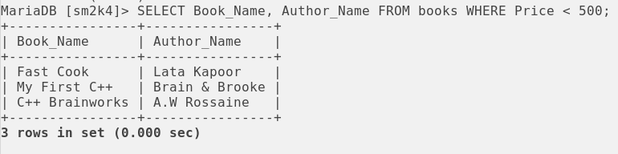
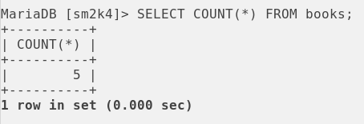

Output.

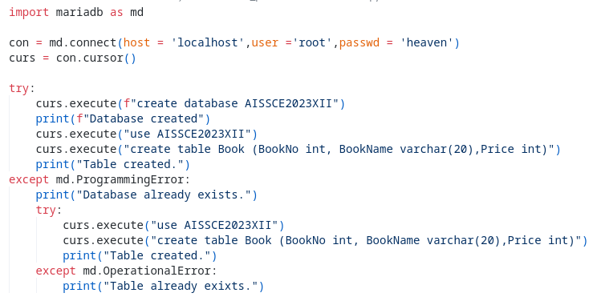
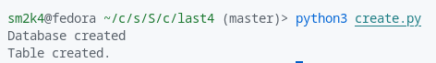

Signature

PFQ12. Write a python program to write and read data from a binary file consisting roll no, name, marks and Update a particular record in the file.

Program.

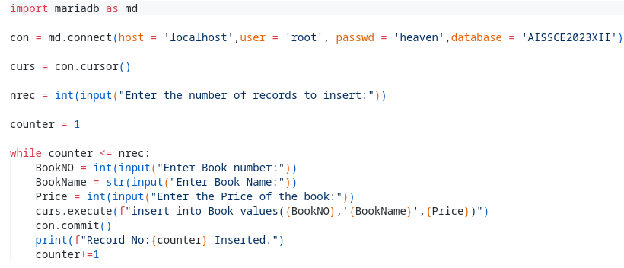
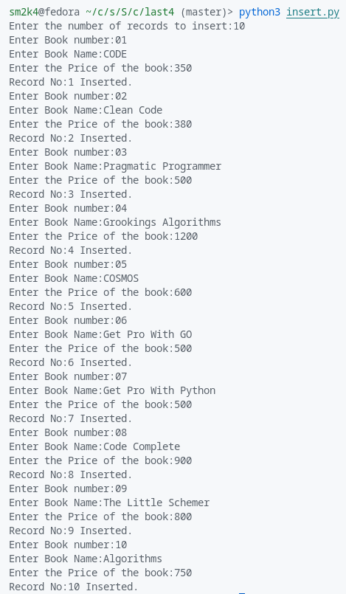

Output.

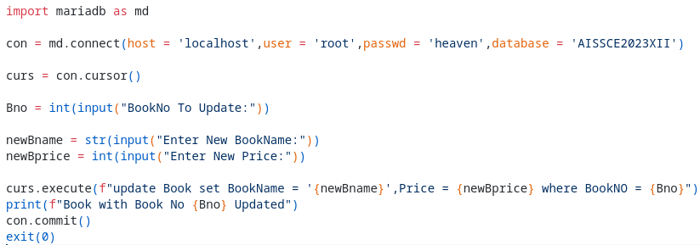
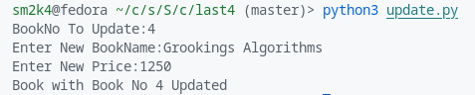

Signature
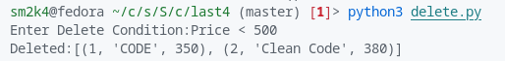
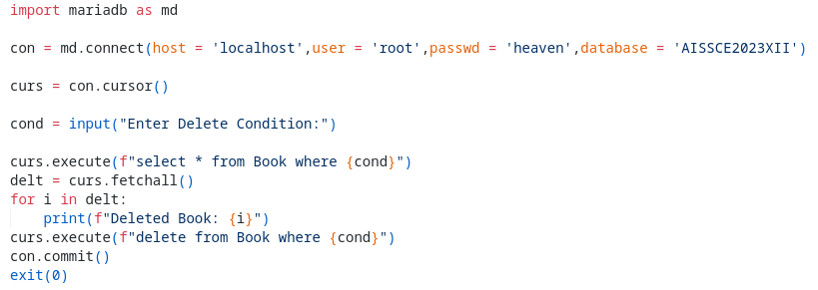
PFQ13. Write a python program to write and read data from a c.s.v file consisting Item-No, Item-Name, Quantity and Price. Write functions to append new records and search for particular record using Item-No.

Program.

Output.

Signature

PFQ14.Write a Menu Driven program to implement a stack for book – details(Book-No, Book-Name). Implement PUSH, POP and DISPLAY operations.
Program.

Output.

Signature

PFQ15.Create a table ITEM with Code as the primary key. Decide your own data types. Insert records as shown in the table below and write the queries to perform the following functions on the table.
Table: ITEM
Code | ItemName | Company | Qty | Price | ExpiryDate
1002 | Cake | Britannia | 45 | 200 | 2013-01-12
1005 | Biscuit | Britannia | 90 | 100 | 2012-12-12
1006 | Jam | Kissan | 34 | 160 | 2013-01-23
1001 | Jelly | Nestle | 23 | 150 | 2012-11-21
1007 | Sauce | Kissan | 120 | 260 | 2013-02-15
1003 | Maggi | Nestle | 80 | 100 | 2013-02-10
1004 | Chocolate | Cadbury | 100 | 200 | 2012-12-27

Program.

Output.
a. Display the details of the items in ascending order of Code.

b. Display Code and ItemName of items that have price in the 170 to 250 range.

c. Display the ItemName and Qty of all the products Expired in 2013.

d. Increase the price of all the items by Rs. 5

e. Display the various company listed in the table.

Signature.
PFQ16. Create a table CLUB with CoachID as the primary key. Decide your own data types. Insert records as shown in the table below and write the queries for the following:
Table: CLUB
CoachID | CoachName | Sports | DateOfApp | Salary | Gender
1001 | Ravindra | Karate | 1990-03-27 | 12000 | M
1002 | Ambika | Karate | 1998-01-20 | 30000 | F
1003 | Nitin | Squash | 1998-02-19 | 15000 | M
1004 | Rohit | Basketball | 1999-04-23 | 18000 | M
1005 | Mohan | Swimming | 1998-02-24 | 30000 | M
1006 | Saumya | Swimming | 2001-01-22 | 15000 | F
1007 | Garima | Karate | 2010-02-27 | 5600 | F
1008 | Shailja | Basketball | 2010-05-29 | 8500 | F

Program.

Output.
a. Display the sum of salaries of the female and the male coaches.

b. Display the maximum and minimum salaries of the Karate coaches.

c. Display the numbers of male and female coaches.

d. Display the details of all coaches whose name end with ‘a’.

e. Display the details of all the coaches associated with sports starting with ‘S’.

Signature.

PFQ17. Create a table PATIENT with Pcode (patient code) as the primary key. Decide your own data types. Insert records as shown in the table and write the outputs for the following:

Table: PATIENT
Pcode | Name | Age | Dept | DOA | Charge | Gender
P1 | Karan | 24 | Surgery | 2010-07-07 | 5000 | M
P2 | Varun | 45 | Orthopedic | 2010-12-19 | 8000 | M
P3 | Ravina | 12 | Orthopedic | 2010-01-15 | 8000 | F
P4 | Ankita | 36 | Surgery | 2009-04-16 | 12000 | F
P5 | Ketan | 16 | ENT | 2009-07-31 | 25000 | M
P6 | Arvind | 29 | ENT | 2010-07-07 | 15000 | M
P7 | Zugal | 45 | Cardiology | 2010-10-20 | 14000 | M

Program.

Output.
a. SELECT * FROM PATIENT WHERE AGE < 25 or AGE > 40;

b. SELECT * FROM PATIENT WHERE DEPT IN (‘ENT’, ‘Surgery’);

c. SELECT MIN(CHARGE), MAX(CHARGE), SUM(CHARGE) FROM PATIENT;

d. SELECT COUNT(*) FROM PATIENT GROUP BY GENDER;

e. SELECT DEPT, COUNT(*) FROM PATIENT GROUP BY DEPT;

Signature.
PFQ18. Given the following tables for a database LIBRARY:
Table: BOOKS

Book_ID | Book_Name | Author_Name | Publishers | Price | Type | Quantity
C0001 | Fast Cook | Lata kapoor | EPB | 355 | Cookery | 5
F0001 | The Tears | Willium Hopkins | First Publ. | 650 | Fiction | 20
T0001 | My First C++ | Brain & Brooke | EPB | 350 | Text | 10
T0002 | C++ Brainworks | A.W. Rossaine | TDH | 350 | Text | 15
F0002 | Thunderbolts | Anna Roberts | First Publ. | 750 | Fiction | 50

Table: ISSUED

Book_ID | Quantity_Issued
T0001 | 4
C0001 | 5
F0001 | 2

Write SQL queries for (a) to (f):

a. To show Book name, Author name and price of books of EPB Publishers.

b. To list the names from books of Fiction type.

c. To display the names and price of the books in descending order of their price.

d. To increase the price of all books of First Publ. Publishers by 50.

e. To display the Book_ID, Book_Name, Quantity_Issued for all books which have been issued?

f. Tim insert a new row in the table issued having the following data: ‘F0002’, 4.

Give the output of the following queries based on the above tables:

->SELECT COUNT(DISTINCT Publishers)FROM BOOKS;

->SELECT SUM(Price) FROM BOOKS WHERE Quantity > 5;

->SELECT Book_Name, Author_Name FROM BOOKS
WHERE Price < 500;

->SELECT COUNT(*) FROM BOOKS;

Signature.

PFQ19. Write a python Program using interface with MySQL to create a database called “AISSCE2023ClassXII” and create a table named “Book” with BookNo, BookName, Price attributes.

Program.

Output.

Signature

PFQ20. Write a python Program using interface with MySQL to insert 10 records in “Book” table.

Program.

Output.

Signature.

PFQ21. Write a python Program using interface with MySQL to update a record based on it’s BookNo.

Program.

Output.

Signature.

PFQ22. Write a python Program using interface with MySQL to delete a particular record(s) based on condition.

Program.

Output.

Signature.

